The Life and Legacy of Mao Zedong

Dr. Emily Matson (艾教授)
Class Time: Wednesdays, 5:00 PM – 7:30 PM
Class Location: Main Campus, Intercultural Center Room 115
E-mail: em1592@georgetown.edu
Office: Intercultural Center Room 620
Office Hours: Wednesdays, 3:30 PM – 4:30 PM and by appointment

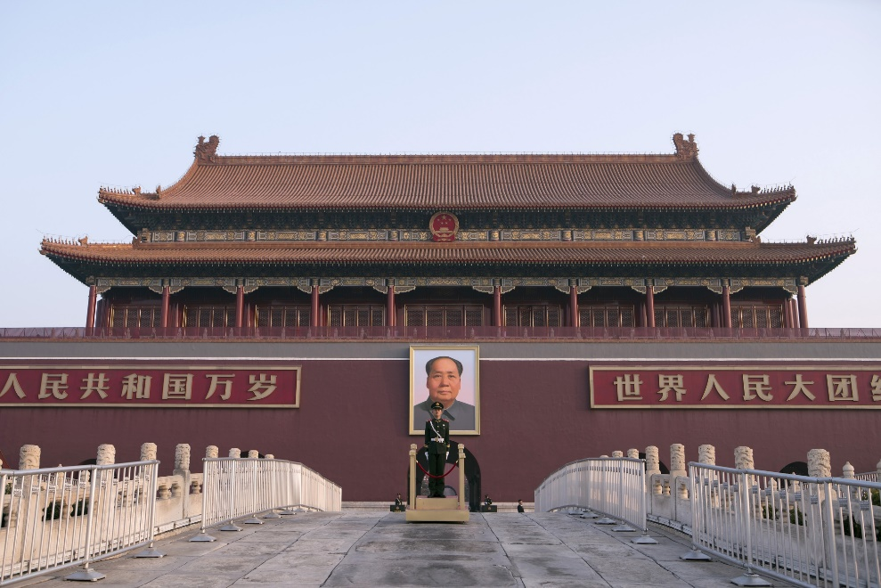

“A revolution is not a dinner party, or writing an essay, or painting a picture, or doing embroidery; it cannot be so refined, so leisurely and gentle, so temperate, kind, courteous, restrained, and magnanimous. A revolution is an insurrection, an act of violence by which one class overthrows another.”

革命不是请客吃饭，不是做文章，不是绘画绣花，不能那样雅致，那样从容不迫，文质彬彬，那样温良恭俭让。革命是暴动，是一个阶级推翻一个阶级的暴烈的行动。

- Mao Zedong, “Report on an Investigation of the Peasant Movement in Hunan,” March 1927

COURSE DESCRIPTION

If you visit Beijing today and go to Tiananmen Square, you’ll see the portrait of Mao Zedong hanging proudly at the entrance to the Forbidden City. Similar to George Washington, Thomas Jefferson, or Abraham Lincoln in the United States, Mao’s legacy continues to shape Chinese identity today. Yet who really was Mao, and what were his views? Few leaders in world history have quite as divisive a legacy. To some, he was a visionary revolutionary who birthed the People’s Republic of China, proclaiming that “the Chinese people have stood up.” To others, he was a tyrannical megalomaniac who brutally suppressed political opposition and murdered millions through tragic historical episodes such as the Great Leap Forward and the Cultural Revolution. Regardless of where one falls on this spectrum, it is impossible to deny the deep impact Mao had on both modern Chinese history and global history in the 20th century.

In this course, we will examine Mao in all his complexity – his life trajectory, the evolution of his writings, and his legacy both within China and internationally. The course objectives are as follows:

- Place Mao Zedong’s life within the context of the shifting contours of 20th century Chinese history and question the validity of the “great man theory.”
- Grasp the basic tenets of Marxism-Leninism-Mao Zedong Thought and its evolution over time both within China and internationally.
- Develop a nuanced understanding of the legacy of Mao and his continued global relevance today.

COURSE MATERIALS
Students are required to purchase copies of the following books for this course:

- Maurice Meisner. Mao Zedong: A Political and Intellectual Portrait. Cambridge: Polity Press, 2007.
- Timothy Cheek, ed. A Critical Introduction to Mao. New York: Cambridge University Press, 2010.
- Jude D. Blanchette, China’s New Red Guards: The Return of Radicalism and the Rebirth of Mao Zedong. New York: Oxford University Press, 2019.
- Julia Lovell. Maoism: A Global History. New York: Vintage Books, 2019.

All other written course materials will either be scanned and uploaded to Canvas or provided via link on the syllabus. Students are required to bring reading materials to class with relevant sections noted and ready for discussion.

ASSIGNMENTS AND GRADING

Participation 30%
- In-Class (10%): All students are expected to attend class regularly. Students are required to come to class prepared with notes and questions on the day’s readings. Participation is mandatory and speaking in class is expected. However, active listening is also a critical part of participation, and this class is intended to be an open forum for discussion amongst students. I also require all students to visit office hours at least once this semester.
- Discussion Leader (10%): The first day of class, I will pass around a sign-up sheet. Students will each sign up to lead one class discussion during the semester. I expect the student leading the discussion to:
- Prepare a series of roughly 10 open-ended questions ahead of time to kick off the discussion.
- Have completed all the readings and incorporated them into the discussion.
- Turn in a 3-4 page reaction paper based on your response to one or more of the questions you have posed.
- Online Discussion (10%): Starting the second week of class, students are required to contribute to that week’s discussion board by Wednesday at 12 PM in preparation for Wednesday’s in-class discussion. You have 3 options for each of your posts, which should be between 200-250 words:
- Create and respond to your own question.
- Respond to a question or a comment posted by one of your classmates.
- Respond to a question posted by the professor.

Midterm Paper 20%: Midterm paper (12 pages double-spaced, not including title page or bibliography) is due October 10 by 5 PM ET on Canvas.

Final Presentation 15%: Presentations will be roughly 10 minutes per student and be conducted in class on November 30th based on your final paper topic.

Final Paper 35%: Final paper (20 pages double-spaced, not including title page or bibliography) is due December 6 by 5 PM ET on Canvas.

CLASSROOM POLICIES
Electronic Devices: Laptops are allowed for taking class-related notes and accessing assigned readings online. However, there is to be no web surfing or use of social media websites during class. If the instructor catches a student web surfing during class, that student will be marked as absent for the day.
Honor Code: You will be expected to adhere to the Georgetown Honor Code, which includes guidance on plagiarism and cheating. Please familiarize yourself on the standards of conduct, which can be found at https://honorcouncil.georgetown.edu/system/policies
SUPPORT
Disability Support: If you have any disabilities that affect your learning or ability to complete the midterm or other assignments, please let me know in private so I can work with you to develop accommodations. Please see the Georgetown policies on Disability Support Services: https://academicsupport.georgetown.edu/disability
Mental Health: For mental health concerns (including stress, anxiety, and depression), please contact Counseling and Psychiatry Services (CAPS) at 202-687-6985. You may also contact me if you are feeling overwhelmed and we can work together to find appropriate accommodations.
Sexual Harassment/Misconduct Policies (Title IX): Please familiarize yourself with Georgetown University’s harassment policies: https://georgetown.app.box/com/s/ecqtjvivcuqsnqpbjxtp
- Here are additional resources at Georgetown related to sexual harassment: https://policymanual.hr.georgetown.edu/1000-university-policies/1004-policy-statement-on-harassment/
- Please note: As a Georgetown University employee, if I become aware of a potential incident of sexual misconduct, I am “required to report to the Title IX Coordinator or a Deputy Title IX Coordinator the details of an incident of sexual misconduct” (including the identities of both the survivor and alleged perpetrator and other relevant facts) so that the University can respond appropriately to maintain a safe campus environment. Note: information disclosed will be treated privately and shared only to the extent necessary to investigate and/or ensure the safety of the campus community.”

CLASS SCHEDULE
The topics and readings listed on this syllabus are tentative, and the instructor may modify readings and topics at any time. Students should pay attention for any such changes. Students should come to class having read the materials listed for that date. While “further background” readings are not required, students are highly encouraged to read them in order to further improve their overall comprehension of the course content.
Class 1 (August 23) – Introduction and Mao’s Early Years
Required:
- Timothy Cheek, “Mao, Revolution, and Memory” in Timothy Cheek, ed., A Critical Introduction to Mao (New York: Cambridge University Press, 2010), pg. 1-30.
- Filip Sebok, “Mao Zedong: Why does the revolutionary leader “live forever”?” in Contemporary China, ed. Kristina Kironska and Richard Q. Turcsanyi (Routledge, 2023), pg. 29-39.

Class 2 (August 30) – Mao as a Feminist(?) and the May Fourth Movement
Required:
- Mao Zedong, “A Study of Physical Education” (1917) and “Miss Zhao’s Suicide” (1919)
- Meisner, Preface and Chapter 1, 1-24
- Delia Davin, “Gendered Mao: Mao, Maoism, and Women” in Timothy Cheek, ed., A Critical Introduction to Mao (New York: Cambridge University Press, 2010), 196-218.

Further Background:
- Zheng Yangwen, “Women’s Liberation in China During the Cold War” in Zheng Yangwen, Hong Liu, and Michael Szonyi, The Cold War in Asia: The Battle for Hearts and Minds (Leiden: Brill, 2010), 119-146.
- Beverly Hooper, “Women in China: Mao versus Confucius,” Labour History 29 (1975): 132-145.

Class 3 (September 6) – Mao and the “Sinicization” of Marxism
Required:
- Mao Zedong, “Report on an Investigation of the Peasant Movement in Hunan” (1927)
- Meisner, Chapters 2-3, pg. 25-71
- Brantly Womack, “From Urban Radical to Rural Revolutionary: Mao from the 1920s to 1937” in Timothy Cheek, ed., A Critical Introduction to Mao (New York: Cambridge University Press, 2010), 61-86.

Further Background:
- Mao Zedong, “Analysis of the Classes in Chinese Society” (1926)
- Julia Lovell, “What Is Maoism?” in Maoism: A Global History (New York: Vintage Books, 2019), 25-59.

Class 4 (September 13) – The Consolidation of Mao Zedong Thought
Required:
- Mao Zedong, “On Contradiction” (1937)
- Meisner, Chapters 4-5, pg. 72-139
- Hung-Yok Ip, “Mao, Mao Zedong Thought, and Communist Intellectuals” in Timothy Cheek, ed., A Critical Introduction to Mao (New York: Cambridge University Press, 2010), 169-195.

Further Background:
- Mao Zedong, “Talks at the Yan’an Forum on Art and Literature” (1942) and “The Chinese People Have Stood Up” (1949)
- Hans J. van de Ven, “War, Cosmopolitanism, and Authority: Mao from 1937 to 1956” in Timothy Cheek, ed., A Critical Introduction to Mao (New York: Cambridge University Press, 2010), 87-109.
- Julia Lovell, “The Red Star – Revolution by the Book” in Maoism: A Global History (New York: Vintage Books, 2019), 60-87.

Class 5 (September 20) – Mao’s Final Two Decades
Required:
- Mao Zedong, “On the Correct Handling of Contradictions among the People” (1957)
- Meisner, Chapters 6-7 and Epilogue, 140-198
- Michael Schoenals, “Consuming Fragments of Mao Zedong: The Chairman’s Final Two Decades at the Helm” in Timothy Cheek, ed., A Critical Introduction to Mao (New York: Cambridge University Press, 2010), 110-128.

Class 6 (September 27) – Mao’s Posthumous Legacy in the PRC
Required:
- Deng Xiaoping, “Resolution on Historical Questions” (1981)
- Jude D. Blanchette, China’s New Red Guards: The Return of Radicalism and the Rebirth of Mao Zedong (New York: Oxford University Press, 2019), 1-103.
- ChinaFile, “Is Mao Still Dead?” (2015)

Further Background:
- Geremie R. Barme, “For Truly Great Men, Look to This Age Alone: Was Mao Zedong a New Emperor?” in Timothy Cheek, ed., A Critical Introduction to Mao (New York: Cambridge University Press, 2010), 243-272.
- Lowell Dittmer, “The Legacy of Mao Zedong,” Asian Survey 20.5 (May 1980), 552-573.

Class 7 (October 4) – Mao’s Legacy in China Today
Guest Speaker (Zoom): Charles Hayford
Required:
- Jude D. Blanchette, China’s New Red Guards: The Return of Radicalism and the Rebirth of Mao Zedong (New York: Oxford University Press, 2019), 104-161.
- Charles W. Hayford, “Mao’s Journeys to the West: Meanings Made of Mao” in Timothy Cheek, ed., A Critical Introduction to Mao (New York: Cambridge University Press, 2010), 313-331
- Xiao Yanzhong, “Recent Mao Zedong Scholarship in China” in Timothy Cheek, ed., A Critical Introduction to Mao (New York: Cambridge University Press, 2010), 273-287.
- Emily Matson, Why it’s misleading to call Xi Jinping the “new Mao” (nuvoices.com), October 2022
- Interview: Joseph Torigian, “Elite Power Struggles after Stalin and Mao,” The Diplomat

Further Background:
- Julia Lovell, “Mao-ish China” in Maoism: A Global History (New York: Vintage Books, 2019), 420-458.

***Midterm paper DUE on Canvas on October 10th by 5 PM ET

Class 8 (October 11) – Mao Goes West
Required:
- Elidor Mehilli, “The Great Leap” and “Afterword: 1991” in From Stalin to Mao: Albania and the Socialist World (Ithaca, NY: Cornell University Press, 2017), 187-225 and 226-232.
- Julia Lovell, “‘You Are Old, We Are Young, Mao Zedong!’ Maoism in the United States and Western Europe” in Maoism: A Global History (New York: Vintage Books, 2019), 266-305.

Further Background:
- Yang Zhang, “Strategic Vigilance: Mao’s “Anti-Peaceful Evolution” Strategy and China’s Policy Towards the United States, 1959-1976,” Journal of Cold War Studies 25.2 (Spring 2023): 93-111.
- Andrew M. Smith, “Which East is Red? The Maoist Presence in the Soviet Union and Soviet Bloc Europe 1956-1980” (Masters Thesis, Georgia State University, Department of History, 2017), pg. 1-65 (double-spaced)

Class 9 (October 18) – Mao, the “Third World,” and Anti-Imperialism
Required:
- Mao Zedong, “The Chinese People Cannot Be Cowed by the Atom Bomb” (1955) and “US Imperialism Is a Paper Tiger” (1956)
- Zachary Scarlett and Samantha Christiansen, ed., “Introduction” in The Third World in the Global 1960s (Berghan Books, 2012), 1-22
- Alexander Cook, “Third World Maoism” in Timothy Cheek, ed., A Critical Introduction to Mao (New York: Cambridge University Press, 2010), 288-312.

Further Background:
- Alexander Cook, “Introduction: The Spiritual Atom Bomb and Its Global Fallout” in Mao’s Little Red Book: A Global History (Cambridge: Cambridge University Press, 2014)

Class 10 (October 25) - Mao, Anti-Imperialism, and the Black Panthers
Guest Speaker: James Gethyn Evans
Required:
- Mao Zedong, “A New Storm against Imperialism” (1968)
- The Black Panthers, “On Chairman Mao’s Declaration of 20 May 1970,” June 20, 1970
- James Gethyn Evans, “Maoism, Anti-Imperialism, and the Third World: The Case of China and the Black Panthers,” Made in China 6.2 (2021)
- Ruodi Duan, “Solidarity in Three Acts: Narrating US black freedom movements in China, 1961-66,” Modern Asian Studies 53.5 (2019), 1351-1380

Further Background:
- Gao Yunxiang, “Introduction” in Arise, Africa! Roar, China! Black and Chinese Citizens of the World in the Twentieth Century (Chapel Hill, NC: The University of North Carolina Press, 2021

Class 11 (November 1) – Maoism in Africa
Required:
- Julia Lovell, “Into Africa” in Maoism: A Global History (New York: Vintage Books, 2019), 185-222
- Jamie Monson, “Introduction” in Africa’s Freedom Railway: How A Chinese Development Project Changed Lives and Livelihoods in Tanzania (Bloomington, IN: Indiana University Press, 2011), 1-14

Further Background:
- Amanda Shuman, “Friendship in Solidarity: The Chinese Ping-Pong Team Visits Africa in 1962” in Simon Rofe, ed., Sports and diplomacy: Games within games (Manchester University Press, 2018), 110-129.
- Yucong Hao, “Afro-Asian resonances: Staging the Congo Crisis in 1960s’ Chinese theatre,” Modern Asian Studies (July 2023), 1-18.

Class 12 (November 8) – Maoism in South and Southeast Asia
Required:
- Julia Lovell, “Mao’s Dominoes? Vietnam and Cambodia” in Maoism: A Global History (New York: Vintage Books, 2019), 223-265.
- Matthew Galway, “Introduction” in The Emergence of Global Maoism: China’s Red Evangelism and the Cambodian Communist Movement, 1949-1979 (Ithaca, NY: Cornell University Press, 2022)

Further Background:
- Julia Lovell, “Nepal – Maoism in Power?” in Maoism: A Global History (New York: Vintage Books, 2019), 384-419.
- “The Khmer Rouge and Global Maoism: Interview with Dr. Matthew Galway by Prof. Felix Wemhuer,” January 12, 2023

Class 13 (November 15) – Maoism in Latin America
Required:
- Julia Lovell, “Red Sun over Peru – The Shining Path” in Maoism: A Global History (New York: Vintage Books, 2019), 306-346
- Daniel Lemus-Delgado, “The Presence of Maoism in Mexico,” Communist and post-communist studies 54.4 (2021), 176-196

Further Background:
- Orin Starn, “Maoism in the Andes: The Communist Party of Peru – Shining Path and the Refusal of History,” Journal of Latin American Studies 27.2 (1995), 399-421
- Matthew Rothwell: “Transpacific Solidarities: A Mexican Case Study on the Diffusion of Maoism in Latin America” in Zheng Yangwen, Hong Liu, and Michael Szonyi, The Cold War in Asia: The Battle for Hearts and Minds (Leiden: Brill, 2010), pg. 183-216

Thanksgiving Break

Class 14 (November 29) – Final Presentations

***Final Papers due on Canvas on December 6th by 5 PM ET

