The Life and Legacy of Mao Zedong

Dr. Emily Matson
Class Time: 8 AM – 9:20 AM
Class Location: James Blair Hall 201
E-mail: emmatson@wm.edu
Office: James Blair Hall 313
Office Hours: Tuesday and Thursday, 9:30-10:30 AM, and by appointment

COURSE DESCRIPTION

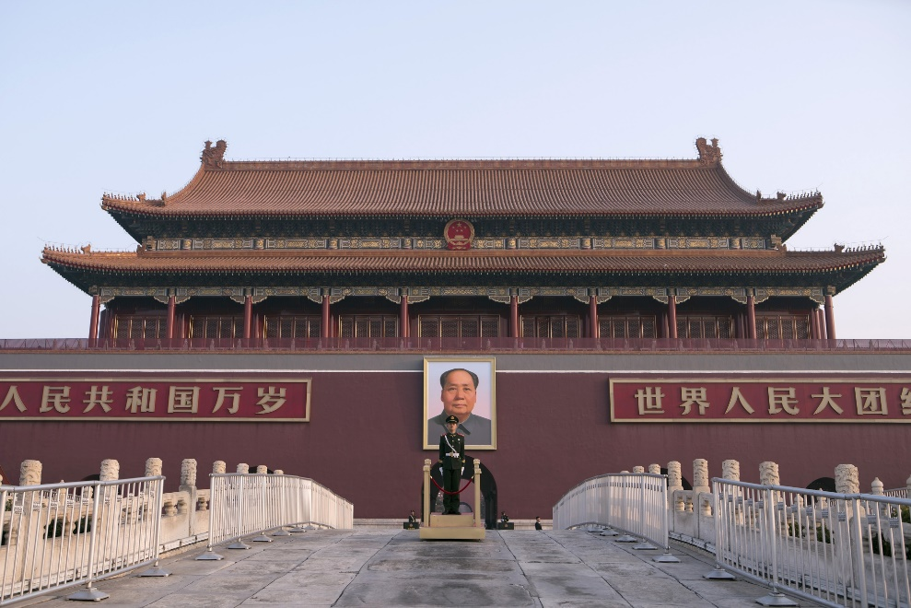

“A revolution is not a dinner party, or writing an essay, or painting a picture, or doing embroidery; it cannot be so refined, so leisurely and gentle, so temperate, kind, courteous, restrained, and magnanimous. A revolution is an insurrection, an act of violence by which one class overthrows another.”

革命不是请客吃饭，不是做文章，不是绘画绣花，不能那样雅致，那样从容不迫，文质彬彬，那样温良恭俭让。革命是暴动，是一个阶级推翻一个阶级的暴烈的行动。农村革命是农民阶级推翻封建地主阶级的权力的革命。农民若不用极大的力量，决不能推翻几千年根深蒂固的地主权力。农村中须有一个大的革命热潮，才能鼓动成千成万的群众，形成一个大的力量。

- Mao Zedong, “Report on an Investigation of the Peasant Movement in Hunan,” March 1927

If you visit Beijing today and go to Tiananmen Square, you’ll see the portrait of Mao Zedong hanging proudly at the entrance to the Forbidden City. Similar to George Washington, Thomas Jefferson, or Abraham Lincoln in the United States, Mao’s legacy continues to shape Chinese identity today. Yet who really was Mao, and what were his views? Few leaders in world history have quite as divisive a legacy. To some, he was a visionary revolutionary who birthed the People’s Republic of China, proclaiming that “the Chinese people have stood up.” To others, he was a tyrannical megalomaniac who brutally suppressed political opposition and murdered millions through tragic historical episodes such as the Great Leap Forward and the Cultural Revolution. Regardless of where one falls on this spectrum, it is impossible to deny the deep impact Mao had on modern Chinese history.

In this course, we will examine Mao in all his complexity – his life trajectory, the evolution of his writings, and how he is remembered today. The course objectives are as follows:

- Question the feasibility of historical objectivity as it relates to the “great man” theory of history in order to develop analytical abilities as scholars.
- Gain the ability to explain “Mao Zedong Thought” and its evolution over time in the context of 20th century Chinese history to a wide variety of audiences in order to improve and expand communication abilities.
- Develop a nuanced understanding of the legacy of Mao and why it is important to Chinese national identity today in order to learn how to draw meaningful connections between the past and the present.

This course fulfills the COLL 100 requirement. The purpose of COLL 100 is to introduce students to a significant question, concept, belief, creative vision, theory, or discovery that has shaped our understanding of the world – in this case, the life and legacy of Mao Zedong. COLL 100 asks students to develop and practice communication skills beyond the written word and into the realms of visual, oral, digital, and/or multi-media expression. To fulfill this requirement, students will develop a podcast on a particular segment of Mao’s writings and the historical context in which he wrote. Throughout the semester students will have multiple opportunities to learn and develop the bibliographic and technological skills required for their projects, especially through library instructional sessions on how to locate sources and create citations.

COURSE MATERIALS

Students are required to purchase copies of the following books for this course:

- Mao Zedong: A Political and Intellectual Portrait. Maurice Meisner (Cambridge: Polity Press, 2007).

All other written course materials will either be scanned and uploaded to Blackboard or provided via link on the syllabus. Students are required to bring reading materials to class with relevant sections noted and ready for discussion.

If you need models for creating your history podcast, here are some excellent examples that you can download for free on Apple Podcasts:

- Back Story, the American History Podcast – https://www.backstoryradio.org/
- The Past, The Promise, The Presidency – https://www.pastpromisepresidency.com/
- Forgotten History of Pacific Asia War – https://www.pacificatrocities.org/forgotten-history-of-pacific-asia-war-podcast.html
- China Whispers – https://www.spectator.co.uk/podcasts/chinese-whispers
- History Unplugged Podcast, Scott Rank
- Revisionist History, Malcolm Gladwell
- The Memory Palace, Radiotopia

ASSIGNMENTS AND GRADING

Map Assignment 5% - This will be a blank map of China that you will need to fill in with the names of major cities, geographical features, and regions. It is available on Blackboard and will be due as a paper copy in class on Tuesday, February 2.

Podcast Assignments:

- Bibliography 5% - After your first visit to Swem (2/24), you will produce a bibliography of 10-15 sources in Chicago Style format on your potential podcast topic, related to Mao Zedong, his writings, and his legacy. The complete rubric is available on Blackboard. You should both upload an electronic copy to Blackboard and bring the paper copy to class on Thursday, March 3.
- Annotated Bibliography 5% - After creating your initial bibliography, you will produce an annotated bibliography of 5+ sources in Chicago Style format on your determined podcast topic. The complete rubric is available on Blackboard. You should both upload an electronic copy to Blackboard and bring the paper copy to class on Thursday, March 10.
- Podcast Elevator Pitch 5% - To practice your oral communication skills, you will give an informal, 1 minute presentation on your podcast’s topic. The complete rubric is available on Blackboard. You will present in class on Tuesday, March 29.
- Podcast Storyboard 5% - This should be an outline of your podcast and include your introduction, your major argument, and the outside research you will be using. The complete rubric is available on Blackboard. You should both upload an electronic copy to Blackboard and bring the paper copy to class on Thursday, April 7.
- Podcast Reflection 5% - This will involve answering a series of targeted questions regarding your podcasts. The complete rubric is available on Blackboard. You should both upload an electronic copy to Blackboard and bring the paper copy to class on Thursday, April 14.
- Podcast 25% - This will be an approximately 30-minute podcast on a topic of your choice. The complete rubric is available on Blackboard. Please upload your podcast to Blackboard by Thursday, April 28.
- Podcast Comments 5% - You are required to listen to 3 of your classmates’ podcasts of your choice and write approximately 1 paragraph for each in which you summarize the podcast’s main argument and detail what you have learned from it. The complete rubric is available on Blackboard. You should both upload an electronic copy to Blackboard and bring the paper copy to class on Thursday, May 5.
- Podcast Presentation 15% - This will be a 5-minute, 5 slide presentation completed at the end of the semester (either Tuesday, May 3 or Thursday, May 5) in which you summarize your podcast research to the class. The complete rubric is available on Blackboard.

Participation 10% - All students are expected to attend class regularly. Students are required to come to class prepared with notes and questions on the day’s readings. Participation is mandatory and speaking in class is highly encouraged. However, active listening is also a critical part of participation, and this class is intended to be an open forum for discussion amongst students. If any student is uncomfortable with speaking during section, please see me early in the semester so that we can come up with other ways to actively contribute.

Final Exam 20% - The final exam will take place during the Exam Period, according to the time designated by the official College of William and Mary exam schedule. It will be a combination of IDs and short essay questions. A study guide will be provided in advance.

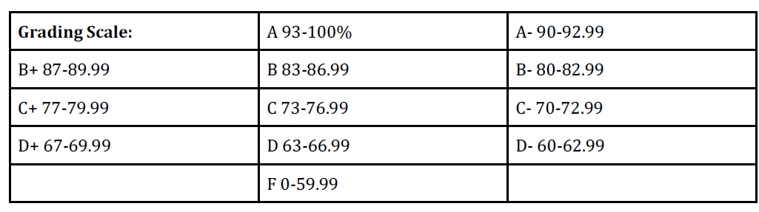
CLASSROOM POLICIES
Electronic devices: Cellphones and other hand-held electronic devices must be turned off during class. Laptops are allowed for taking class-related notes and accessing assigned readings online. However, there is to be no web surfing during class. If the instructor catches a student web surfing during class, that student will be marked as absent for the day. The instructor also reserves the right to revoke laptop use at any time for all students (except those who require laptops for notetaking and can provide documentation from the Coordinator of Disability Services stating this).
Student athletes: Please let me know your sports schedule ahead of time, and you will be able to miss up to two classes for athletic competitions with no penalty. However, you are still responsible for any missed work. If your sports schedule conflicts with more than 3 class meetings, please meet with me during my office hours early in the semester to make alternate arrangements. In accordance with NCAA regulations, you are not allowed to miss class for practices. If you must miss class for a competition you are advised to minimize any further absences from this class.
Plagiarism: Plagiarism is a serious honor violation for which there are severe penalties. In short, in your papers you must provide notes giving credit for all ideas of other authors that you use. In addition, when you use direct quotation from a source, you must both include a note citing your source and enclose the quoted matter in quotation marks (unless you are dealing with a long quotation, in which case the quote is put in blocked form, indented from the left margin, without quotation marks). Most of the time you should avoid quotation, instead paraphrasing the source you are using—and, of course, giving credit to your source in a note. It is not enough to substitute a few words or change them around in order to make a paraphrase; a paraphrase must be in your own words—and sentence structure. A true paraphrase does not require quotation marks, but it does require a note. Please feel free to ask me if you have questions about any of this.
COVID-19
This semester, the world will enter its third year with COVID. As we experience a fifth surge of pandemic with the highly transmissible omicron variant, it is reasonable to expect significant levels of infection at W&M. As an academic community based on faculty and students convening, spring 2022 courses will largely consist of in-person instruction. All of us will follow W&M requirements - vaccinations and boosters, indoor masking, as well as quarantine and isolation when ill. That last is really important: for those who have tested positive, W&M’s requirements must be fulfilled before class can be attended in person, and, out of an abundance of caution, anyone with symptoms consistent with COVID – even if they don’t have a positive test – should not come to class.

Please note that testing positive for COVID or any other temporary illness is not considered a disability as defined by ADA guidelines and is not under the purview of W&M’s Student Accessibility Services (SAS). Thus, any questions should be addressed via email to the instructor.

If you cannot come to class due to a temporary illness, please email me before class so that I can arrange a make-up assignment for you. Students who do not email me before class in the case of an absence will, with the exception of extenuating circumstances, accrue an unexcused absence. If the instructor is absent due to a temporary illness, we will conduct class over Zoom in the instructor’s personal Zoom room. A reminder and the Zoom link will be emailed to you the evening before class.

SUPPORT
Dean of Students Office: If you have a personal crisis of any kind during the semester, the Dean of Students Office can provide support. They will also notify your professors while maintaining privacy. The office is located in Campus Center 109. You can also reach staff via telephone at (757)221-2510 or by email at deanofstudents@wm.edu.
Student Accessibility Services: The College of William and Mary is committed to providing learning experiences that are accessible for all students and will make reasonable accommodations for individuals with documented disabilities. If you have a learning difference or a disability – mental health, medical, or physical impairment – please contact the Student Accessibility Services staff at (757)221-2512 or at sas@wm.edu to determine if accommodations are warranted and to obtain an official letter of accommodation. For more information, please visit www.wm.edu/sas.
Counseling Center: For mental health concerns (including stress, anxiety, and depression), the Counseling Center (WMCC) can provide consultations and connect you with support to resources both on and off campus. The center is located in Blow Hall 240, and can be reached at (757)221-3620.
Writing Centers: The A&S Writing Resource Centers are available to work with students on their writing and communication assignments. These include the Writing Resources Center (WRC) and the History Writing Resources Center (HWRC). You can find more information on each center on their individual websites: www.wm.edu/as/wrc and www.wm.edu/as/history/undergraduateprogram/hwrc.
CLASS SCHEDULE
The topics and readings listed on this syllabus are tentative, and the instructor may modify readings and topics at any time. Students should pay attention for any such changes. Students should come to class having read the materials listed for that date.
January 28, Session 1 – Introduction

February 1, Session 2 – Mao’s Early Years
- Meisner, Preface and pg. 1-5
- Timothy Cheek, “Mao, Revolution, and Memory”
- Introduction to podcasts
- Map Assignment DUE

February 3, Session 3 – Mao and the May Fourth Movement
- Meisner, pg. 5-24
- Mao Zedong, “A Study of Physical Education” (1917) - https://www.marxists.org/reference/archive/mao/selected-works/volume-6/mswv6_01.htm
- Mao Zedong, “To the Glory of the Hans” (1919) - https://www.marxists.org/reference/archive/mao/selected-works/volume-6/mswv6_03.htm

February 8, Session 4 – NO CLASS

February 10, Session 5 – Mao as a Feminist
- Mao Zedong, “Miss Zhao’s Suicide” (1919) – https://www.marxists.org/reference/archive/mao/works/1919/miss-chao.htm
- Quotations from Mao on Women - https://www.marxists.org/reference/archive/mao/works/red-book/ch31.htm
- “Women in China: Mao versus Confucius,” Beverly Hooper
- Class on Zoom

February 15, Session 6 – Mao Converts to Communism
- Meisner, Chapter 2
- Mao Zedong, “Analysis of the Classes in Chinese Society” (1926) – https://www.marxists.org/reference/archive/mao/selected-works/volume-1/mswv1_1.htm
- In class: brainstorm podcast topics

February 17, Session 7 – Mao and the Discovery of the Peasantry
- Meisner, pg. 42-52
- Mao Zedong, “Report on an Investigation of the Peasant Movement in Hunan” (1927) – https://www.marxists.org/reference/archive/mao/selected-works/volume-1/mswv1_2.htm

February 22, Session 8 – Mao and the Jiangxi Soviet
- Meisner, pg. 52-71
- Mao Zedong, “Preliminary Conclusions of the Land Investigation Campaign” - https://www.marxists.org/reference/archive/mao/selected-works/volume-6/mswv6_16.htm

February 24, Session 9 – Library Visit

March 1, Session 10 – Mao, the Long March, and Nationalism
- Meisner, pg. 72-82
- “Interviews with Mao Zedong” by Edgar Snow (1936) - https://www.marxists.org/reference/archive/mao/works/1936/11/x01.htm

March 3, Session 11 – The Formation of Mao Zedong Thought
- Meisner, 83-96
- Mao Zedong, “On Practice” (1937) - https://www.marxists.org/reference/archive/mao/selected-works/volume-1/mswv1_16.htm
- Mao Zedong, “On Contradiction” (1937) - https://www.marxists.org/reference/archive/mao/selected-works/volume-1/mswv1_17.htm
- Bibliography DUE

March 8, Session 12 – Mao and the War with Japan
- Van de Ven, “War, Cosmopolitanism, and Authority: Mao from 1937 to 1956”
- Mao Zedong, “Combat Liberalism” (1937) - https://www.marxists.org/reference/archive/mao/selected-works/volume-2/mswv2_03.htm
- Mao Zedong, “On Protracted War” (1938) - https://www.marxists.org/reference/archive/mao/selected-works/volume-2/mswv2_09.htm

March 10, Session 13 – Media Center Visit
- Annotated Bibliography DUE

March 15 – Spring Break, NO CLASS

March 17 – Spring Break, NO CLASS

March 22, Session 14 – Mao, the Yan’an Way, and Art and Literature
- Mao Zedong, “On New Democracy” (1940) – https://www.marxists.org/reference/archive/mao/selected-works/volume-2/mswv2_26.htm
- Mao Zedong, “Talks at the Yan’an Forum on Art and Literature” (1942) – https://www.marxists.org/reference/archive/mao/selected-works/volume-3/mswv3_08.htm

March 24, Session 15 – Mao and the Chinese Civil War
- Meisner, 97-105
- Mao Zedong, “On Coalition Government” (1945) - https://www.marxists.org/reference/archive/mao/selected-works/volume-3/mswv3_25.htm

March 29, Session 16 – Mao and the Formation of the People’s Republic of China
- Meisner, Chapter 5
- Mao Zedong, “The Chinese People Have Stood Up” (1949) - https://www.marxists.org/reference/archive/mao/selected-works/volume-5/mswv5_01.htm
- One-minute in-class presentations: podcast elevator pitches

March 31, Session 17 – Mao and the Nationalities Question
- Thomas S. Mullaney, “Identity Crisis in Postimperial China”
- Mao Zedong, “Criticize Han Chauvinism” (1953) - https://www.marxists.org/reference/archive/mao/selected-works/volume-5/mswv5_25.htm
- Mao Zedong, “On the Ten Major Relationships” (1956) - https://www.marxists.org/reference/archive/mao/selected-works/volume-5/mswv5_51.htm

April 5, Session 18 – Mao and Imperialism
- Mao Zedong, “Our Great Victory in the War to Resist US Aggression and Aid Korea and Our Future Tasks” (1953) - https://www.marxists.org/reference/archive/mao/selected-works/volume-5/mswv5_34.htm
- Mao Zedong, “The Chinese People Cannot Be Cowed by the Atom Bomb” (1955) - https://www.marxists.org/reference/archive/mao/selected-works/volume-5/mswv5_40.htm
- Mao Zedong, “US Imperialism Is a Paper Tiger” (1956) - https://www.marxists.org/reference/archive/mao/selected-works/volume-5/mswv5_52.htm
- Mao Zedong, “Oppose Radical Discrimination by US Imperialism” (1963) - https://www.marxists.org/reference/archive/mao/selected-works/date-index.htm
- Mao Zedong, “A New Storm against Imperialism” (1968) - https://www.marxists.org/reference/archive/mao/selected-works/volume-9/mswv9_80.htm

April 7, Session 19 – Mao and the Great Leap Forward
- Meisner, Chapter 6
- Mao Zedong, “On the Cooperative Transformation of Agriculture” (1955) – https://www.marxists.org/reference/archive/mao/selected-works/volume-5/mswv5_44.htm
- Podcast Storyboard DUE

April 12, Session 20 – Mao and the Great Leap Forward, cont.
- Schoenals, “Consuming Fragments of Mao Zedong: The Chairman’s Final Two Decades at the Helm”
- Mao Zedong, “Have Firm Faith in the Majority of the People” (1957) – https://www.marxists.org/reference/archive/mao/selected-works/volume-5/mswv5_68.htm
- Mao Zedong, “On the Correct Handling of Contradictions Among the People” (1957) – https://www.marxists.org/reference/archive/mao/selected-works/volume-5/mswv5_58.htm

April 14, Session 21 – Mao versus the Party
- Meisner, 161-167
- Mao Zedong, “Summing up Ten Years” (1960) - https://www.marxists.org/reference/archive/mao/selected-works/volume-8/mswv8_53.htm
- Mao Zedong, “Speech at the Ninth Plenum of the Eighth CPC Central Committee” (1961) – https://www.marxists.org/reference/archive/mao/selected-works/volume-8/mswv8_59.htm
- Podcast Reflections DUE

April 19, Session 22 – Mao and the Cultural Revolution
- Meisner, Chapter 7
- Mao Zedong, “A Letter to the Red Guards of Tsinghua University Middle School” (1966) - https://www.marxists.org/reference/archive/mao/selected-works/volume-9/mswv9_60.htm
- Mao Zedong, “Interjection at Large Meeting of the CCPCC Standing Committee” (1966) – https://www.marxists.org/reference/archive/mao/selected-works/volume-9/mswv9_62.htm
- Mao Zedong, “Directives Regarding Cultural Revolution” (1966-69) – https://www.marxists.org/reference/archive/mao/selected-works/volume-9/mswv9_84.htm

April 21, Session 24 – Mao and the Cultural Revolution, cont.
- Mao Zedong, “Twenty Manifestations of Bureaucracy” (1970) – https://www.marxists.org/reference/archive/mao/selected-works/volume-9/mswv9_85.htm
- Mao Zedong, “People of the World, Unite and Defeat the US Aggressors and All Their Running Dogs” (1970) – https://www.marxists.org/reference/archive/mao/selected-works/volume-9/mswv9_86.htm

April 26, Session 23 – Mao’s Death and His Legacy under Deng Xiaoping
- Meisner, Epilogue
- Deng Xiaoping, “Resolution on Historical Questions” (1981) – https://www.marxists.org/reference/archive/deng-xiaoping/1981/15.htm

April 28, Session 25 – Mao’s Legacy in the 1980s through 2000s
- Lowell Dittmer, “The Legacy of Mao Zedong”
- “From Mao Zedong to Xi Jinping: How China’s Communist Party Leaders Have Shaped Its Ideology” – https://www.scmp.com/news/china/politics/article/3139347/mao-xi-how-chinas-communist-party-leaders-have-shaped-its
- Podcast DUE

May 3, Session 26 – The Legacy of Mao under Xi Jinping
- “Xi Jinping Wants to Become the New Mao” – https://www.cato.org/commentary/xi-jinping-wants-become-new-mao
- “How Xi Jinping’s China Differs from Mao’s” – https://www.economist.com/china/2021/10/14/how-xi-jinpings-china-differs-from-maos
- “Xi Jinping Aims to Rein in Chinese Capitalism, Hew to Mao’s Socialist Vision” – https://www.wsj.com/articles/xi-jinping-aims-to-rein-in-chinese-capitalism-hew-to-maos-socialist-vision-11632150725
- 5-minute, 5 slide podcast presentations

May 5, Session 27 – Is Mao Still Dead?
- “Is Mao Still Dead?” – https://www.chinafile.com/conversation/mao-still-dead
- “Why Maoism Still Resonates in China Today” – https://www.washingtonpost.com/politics/2019/05/29/why-maoism-still-resonates-china-today/
- “Mao’s Global Legacy of Revolution and Bloodshed” – https://www.wsj.com/articles/maos-global-legacy-of-revolution-and-bloodshed-11570206029
- 5-minute, 5 slide podcast presentations, cont.
- Podcast comments DUE

